SMART INVENTORY MANAGEMENT SYSTEM

System Requirements Specification Document v 1.0

Nilay Das

Table of Contents:

Introduction 3
Scope: 3
Assumptions 3
Management Summary 4
System Objectives / Overview 4
Figure 1 System Context Diagram 5
Refrences 6
Initial requirement document 6
Common requirements: 6
Message Sequencing Requirements 6
Message Persistence Requirements 6
Message Size Requirements 7
Error & Exception Handling Requirements 7
Auditing/Logging Requirements 7
Functional Requirement 1 – Implement the Blanket order generation 7
Brief Description 7
Interface Details 7
Table of requirement 8
Functional Requirement 2 – Tenders Generated by IMS for pistons inventory 9
Brief Description 9
Table of requirement 10
Database Schema: 11
SQL Script for table creation: 11
Test Cases: 11
Unit Test Cases – SIMS 11
Integration Test Cases – SIMS 12
NFR – Test cases 12
XML Schema 12
Adhoc Reporting 12
Disclaimer 13
Products to be used: 13
Resource & References: 15

Introduction

Scope:

This document describes the scope of the requirements for the Smart Inventory Management System (SIMS) for ABC Corp. The document details all the high level requirements with intent to validate ABC’s requirements. This document should be used by the Architect and the developers to design the Solution Architecture for the project.
In addition to this, the document also describes the broad scope of the project. The scope of the project involves the integration of a subset of all the components of current IT
Environment.
The key system that is involved in the integration is the Inventory Management System (IMS). The integration is enabled by having a message oriented middleware
There are a total of 2 business use cases or interfaces that have to be enabled through the integration. The scope of the project involves the development of these 2 interfaces that will integrate the IMS with the SIMS. The project is to be deployed in the development environment of ABC corp. Eventual deployment into production will be effected to all geographies that use the IMS.

Assumptions

The following are the assumptions for this document
· It is assumed that the IMS continues to generate XML messages based on the schema provided and there wont be any change in the schema.

Management Summary

ABC is an MNC involved in automobile parts & accessories manufacturing spread across various geographies. ABC has already acquired XYZ Inc which specializes in pistons manufacturing for high performance engines. ABC is now in process of integrating the XYZ systems & applications with that of the parent Application and also eyes in future expansions by acquiring other companies in the vertical. ABC already has IMS which manages the inventories and accordingly generates tender and also selects the best quote. Since ABC has already acquired XYZ who specializes in pistons making, the new SIMS application should mediate the tenders placed by IMS and make sure pistons related tenders are not going out to vendors. Likewise IMS doesn’t have the functionality of blanket order where by some of the raw materials like screws and nuts are always required in huge quantities with the inventories. ABC has decided to place blanket orders once in two days. ABC also wants the property of configuring the quantity of a inventory in a blanket order and also the time duration for placing blanket orders to be customizable.

System Objectives / Overview

IMS
Vendors/XYZ

SIMS
Tenders/Orders
Quotes
Tenders/Orders/Blanket Orders

Figure 1 System Context Diagram

The diagram above explains the main conceptual elements in the solution and its
Relationships with the architecture. The central SIMS component interacts with both IMS and vendors. Requests to system come from IMS. For all tenders, it checks for Pistons in the tender and take appropriate action.
If tender for pistons along with other inventories has been generated, it deletes the pistons element in the payload and sends rest of the tender as it is, to the vendors. It then sends the pistons requirement as an order from the tender to XYZ department which ABC has acquired.
If no pistons tender in the payload then it sends the actual payload to the vendor.
If order request comes in, IMS sends it to the particular vendor to whom the order is placed to supply the inventories.

IMS | Already existing Inventory management system. It can generate Tenders and orders.
SIMS | Smart inventory management system which is going to be built. It can handle tenders/orders and also generates blanket orders/pistons order and take appropriate actions based on the type of request.
XYZ | The company acquired by ABC. XYZ is involved in producing pistons for high performing engines.
Vendors | Already existing vendors who supply the orders based on the best quote arrived at IMS for the tenders.

Refrences:

Initial requirement document –



Common requirements:

Message Sequencing Requirements
There are no specific sequencing requirements between any two kinds of requests coming
from the requesting applications such as Tenders or Orders from IMS.

Message Persistence Requirements
All messages that will arrive on WebSphere MQ queues should be persistent. However,
TCPIP communication is not persistent. It will be the responsibility of the sending application to persist the information.

Message Size Requirements
There are no specific size requirements from the customer. The application will handle any size of the message supported by WebSphere MQ.

Error & Exception Handling Requirements
If an error is encountered in a messaging operation at SIMS, it should retry sending the message. The retry interval should be configurable. It can retry up to three times after which it has to raise it as an error and also log the message.

Auditing/Logging Requirements
ABC expects all the messages going through the WebSphere MQ to be
audited for future use. This feature should be configurable and there should be options
provided to switch ON and switch OFF auditing. Auditing is expected only for the incoming and outgoing messages only and there is no need for debugging of these messages at runtime. It is required to persist the incoming and outgoing message in a persistent storage system.

Functional Requirement 1 – Implement the Blanket order generation

Brief Description
The SIMS should be capable of generating blanket orders at regular intervals to few of the pre configured inventories. But the quantity of the order should be customizable. For example the SIMS should place an order for 2” screws in 1000 nos. by default. But it can also be customized whereby if the administrator can mention the default to 750 as well as override it to any numbers.

Interface Details
The following schematic explains the sequence in blanket order generation.

SIMS

Config File/DB

Duration – 24 hours

Inventory - Quantity
screws – 1000
nuts - 450
Blanket orders

Vendors

Table of requirement
Flow | The SIMS will generate blanket orders at corresponding time that has been mentioned in the config. It takes out the inventories mentioned in the config and their quantities and generates an XML payload based on the blanket order schema and sends it to the vendors to supply. It also updates the DB about the order details.
Exception Handling | The programmatic exceptions arising out of connections to EIS or MQ needs to be retried for three times and if it fails then it should be raised as errors and logged. The time between the retries is configurable.

Functional Requirement 2 – Tenders Generated by IMS for pistons inventory

Brief Description
Since ABC has acquired XYZ who specializes in pistons manufacturing, the SIMS should look into the tenders if any tender for pistons is present in the tender. If it is present then SIMS has to cut it out of the message and send the rest of the message as a tender. SIMS should then generate a order to XYZ with the pistons description as found in the earlier tender which was sent to vendors without the pistons information. It should also update the database about the the order.
Pistons Order

Tenders with other inventories

Tenders with pistons & other inventories

SIMS

IMS

Vendors

XYZ

Table of requirement
Flow | For each tender generated by IMS, SIMS will look into that if any tender for pistons has been generated in that. If no pistons tender is present inside the tender then it routes the tender message to the vendors. If it happens to get a tender with pistons along with other inventories, then it cuts the pistons requirement in the tender as an order and place it to the XYZ department and send the rest of xml to the vendors.
Exception Handling | The programmatic exceptions arising out of connections to EIS or MQ needs to be retried for three times and if it fails then it should be raised as errors and logged. The time between the retries is configurable.

Database Schema:

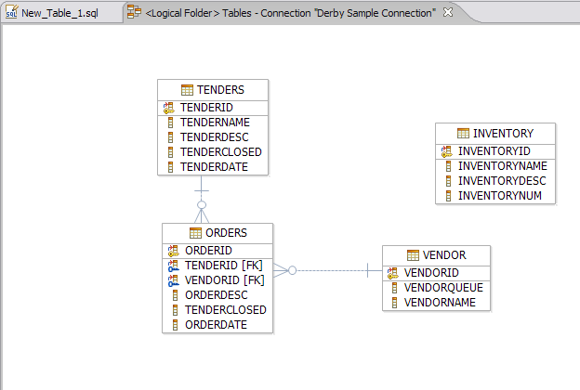

SQL Script for table creation:

This DB scrips were prepared against the derby DB for the above topology.



Test Cases:

Unit Test Cases – SIMS



Integration Test Cases – SIMS

NFR – Test cases

XML Schema

Schema for Tenders from IMS
Schema for orders from IMS
Schema for blanket orders from SIMS.
Schema for orders from SIMS to XYZ department for pistons.

Adhoc Reporting

As a last minute requirement, ABC wants a reporting module for the blanket orders that got generated. The screen requirement is as under.

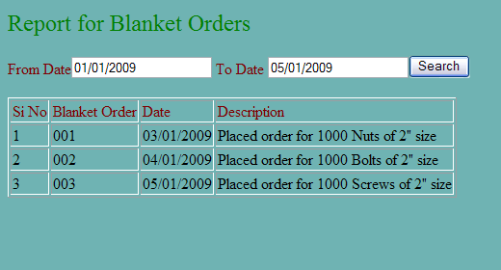

Disclaimer

Most of the DB requirements are captured in the specification. But while developing the solution if the developer has a valid point to add more fields then it can be accommodated after consultation since the DB schema is not freezed as yet.

Products to be used:
Scenario | Product | Description
Developing Use case & UML related activites | Violate | All the UML related specs needs to be developed using Violate only.
Development | Eclipse | The development of Java/J2EE artifacts should Eclipse
Database | MySql | For all the DB requirements, the team should use IBM DB2 only
Team repository | Tortoise | The project team should share there artifacts between them using Rational Tortoise only.
Deployment – Java/J2EE solutions | JBoss Application Server | The team should deploy their solutions for testing/production on JBoss Application Server
Deployment – Message Oriented Middleware | JMS | For all the messaging requirements in the solution, the team should JMS Only

